Nama : Viona Paramitha

Kelas : 5C

NIM : 18090097

Praktikum 5

1. Source Code : autoload.php >>> application/config/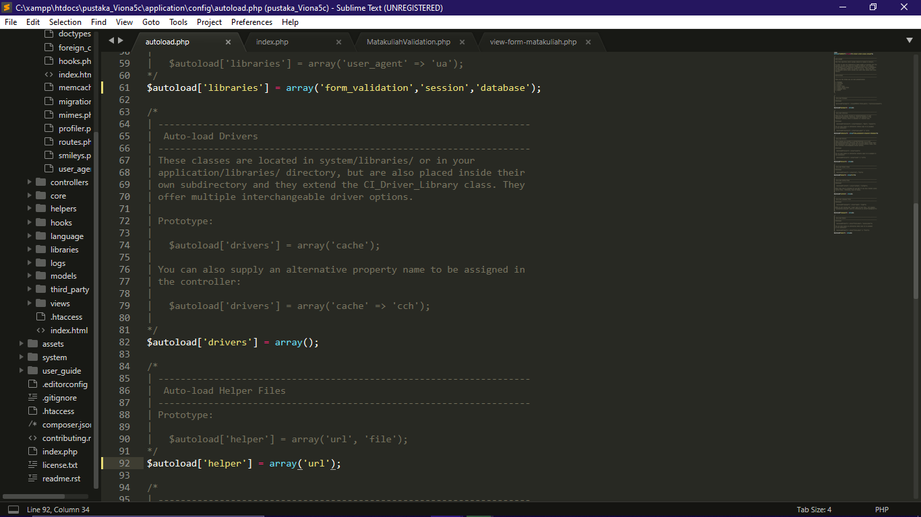

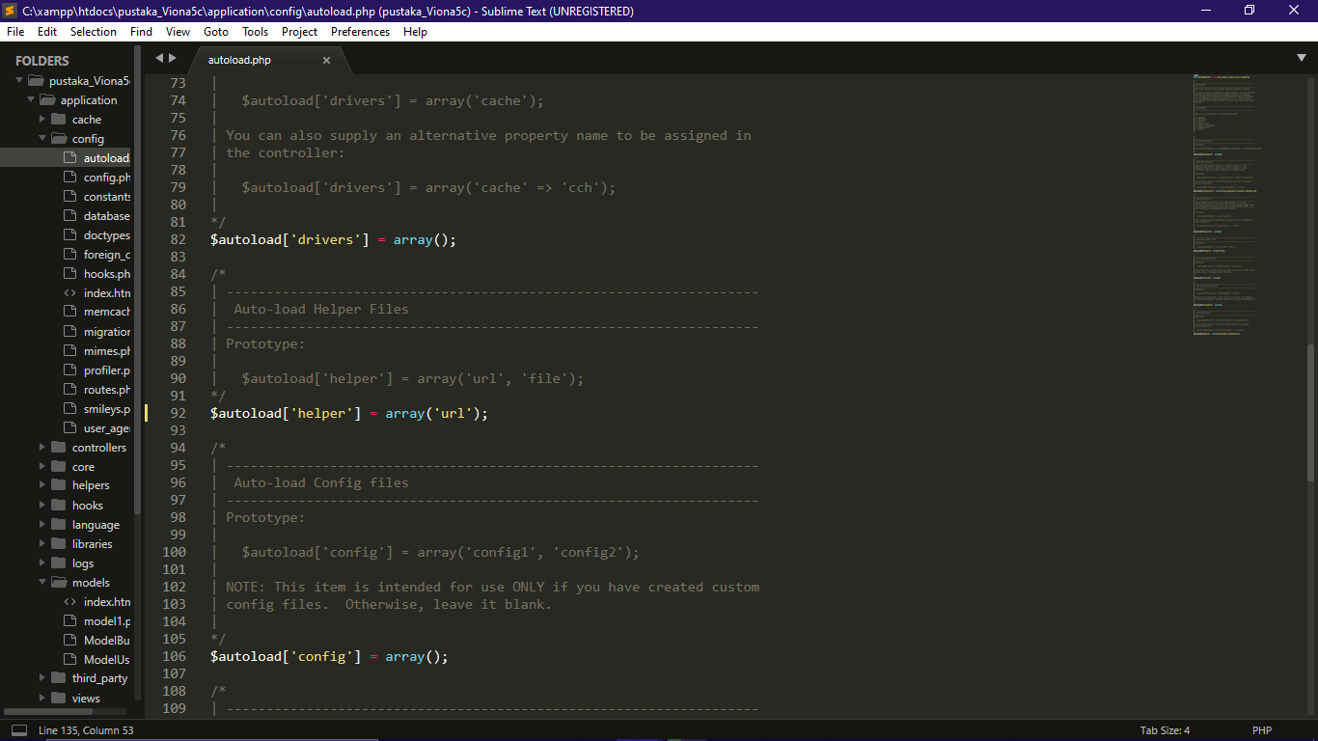

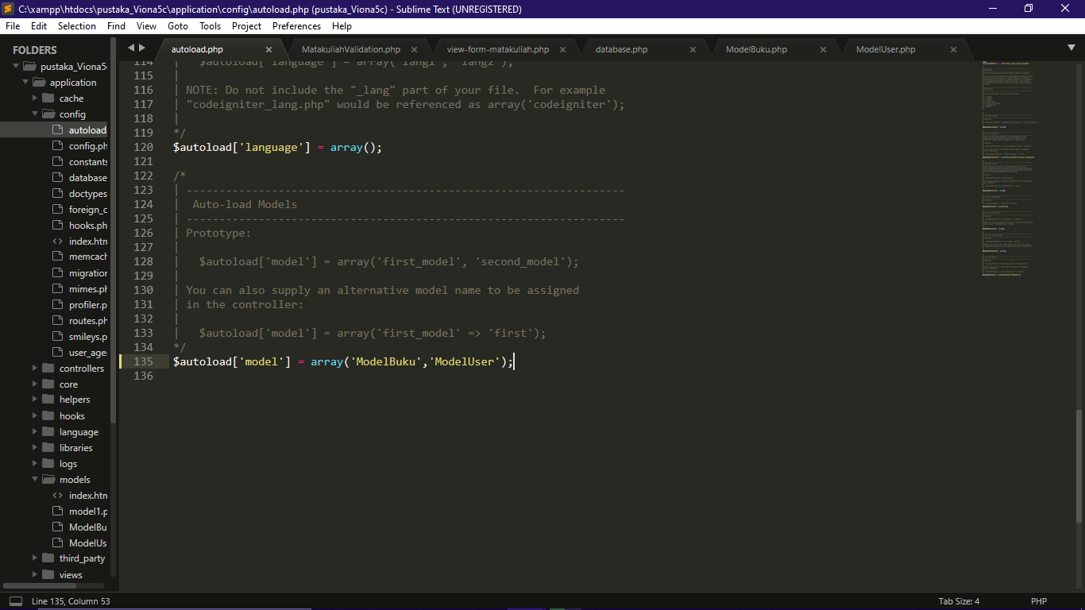

1. Source Code : database.php >>> application/config/

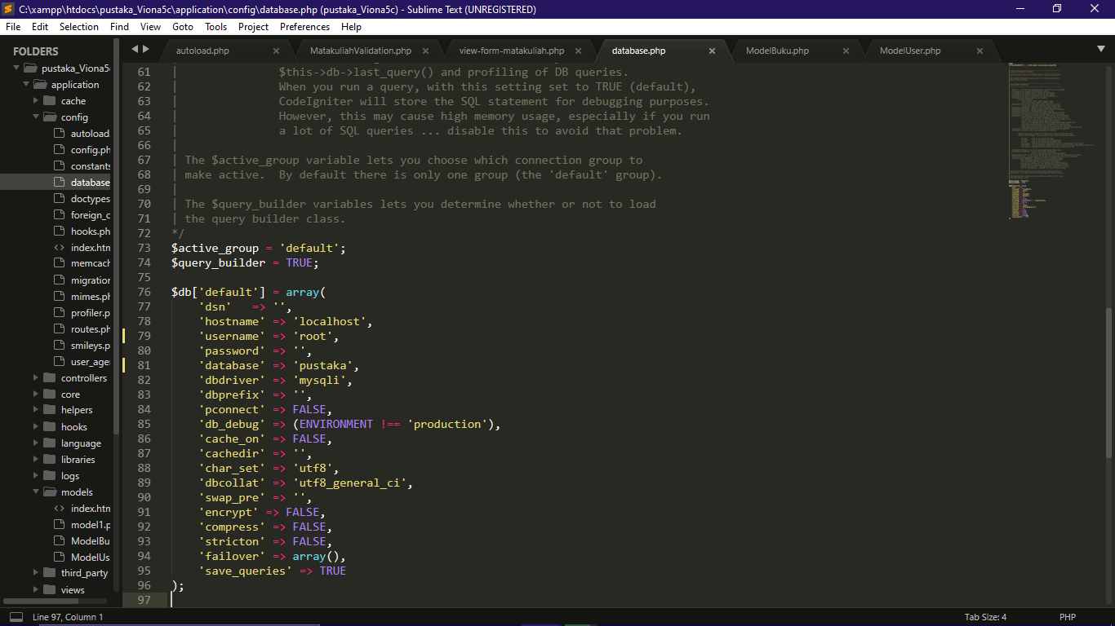

1. Source Code : ModelBuku.php >>> application/models/

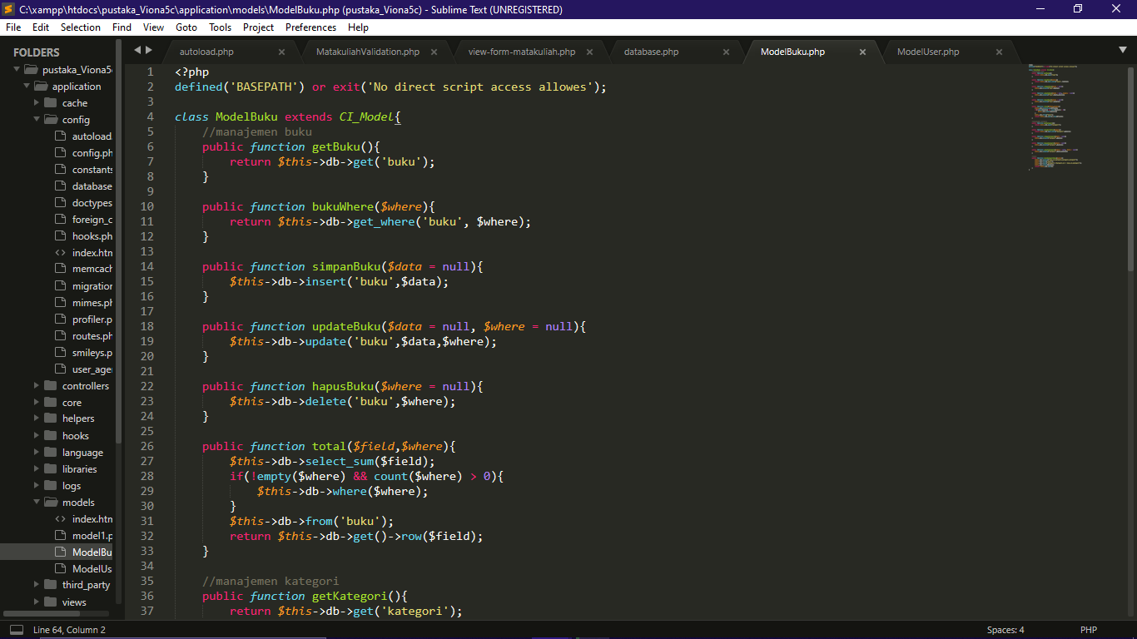

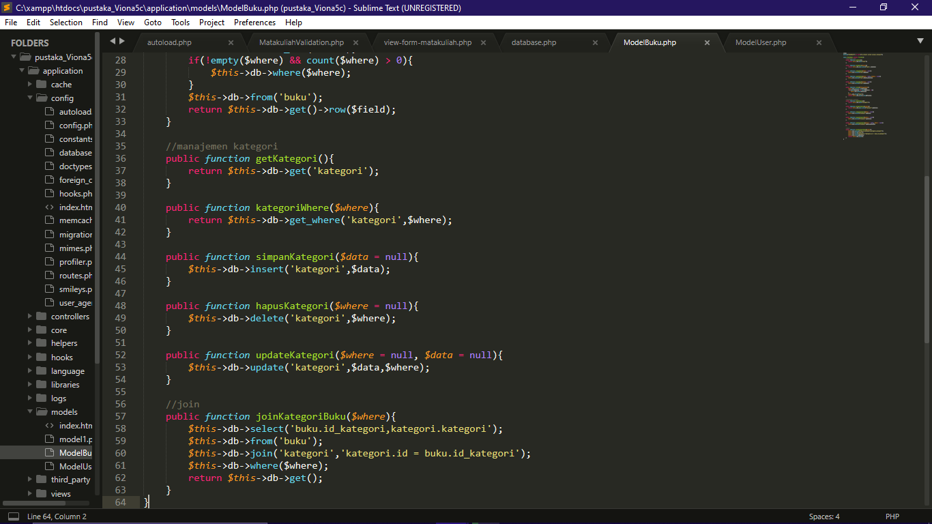

1. Source Code : ModelUser.php >>> application/models/

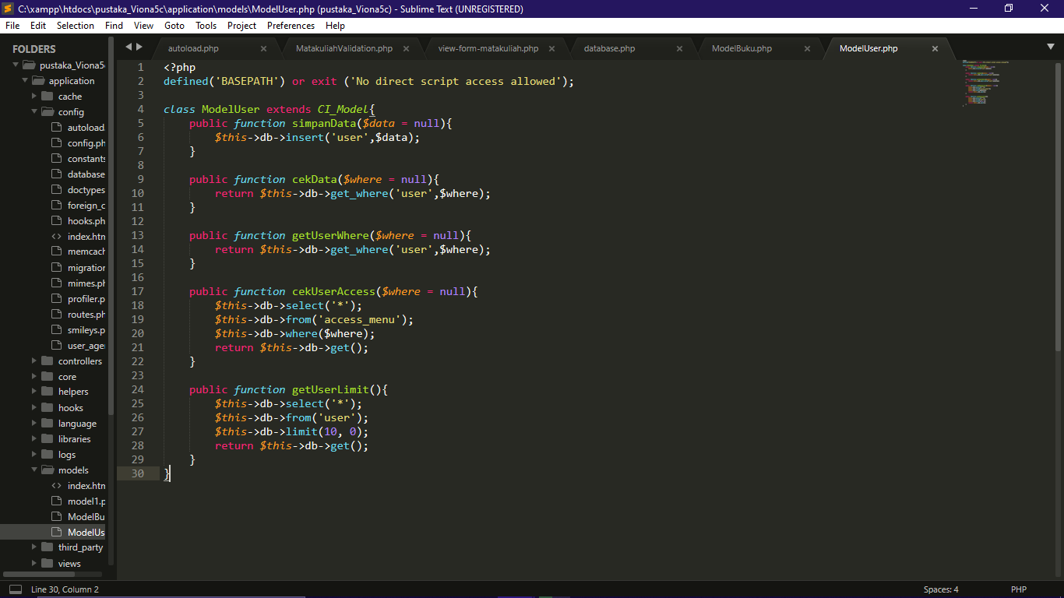

Membuat Database Pustaka

1. Tabel User (user)

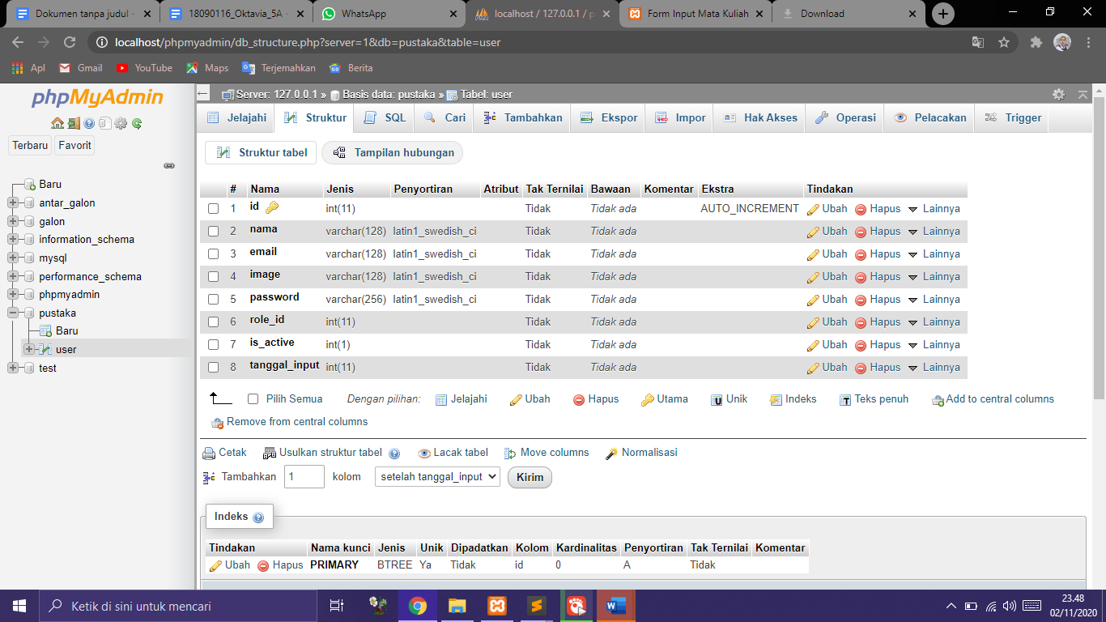

1. Tabel Role (role)

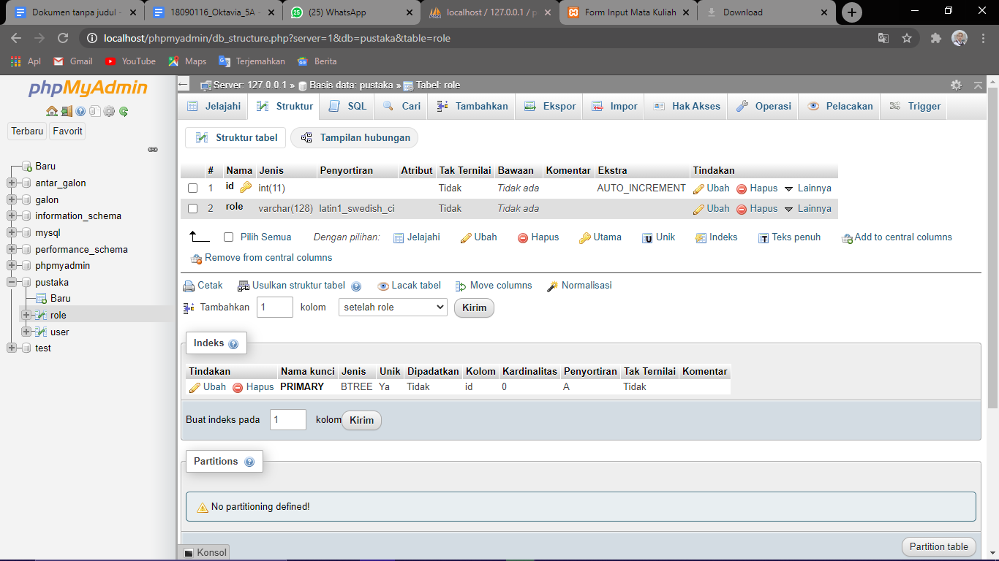

1. Tabel Kategori (kategori)

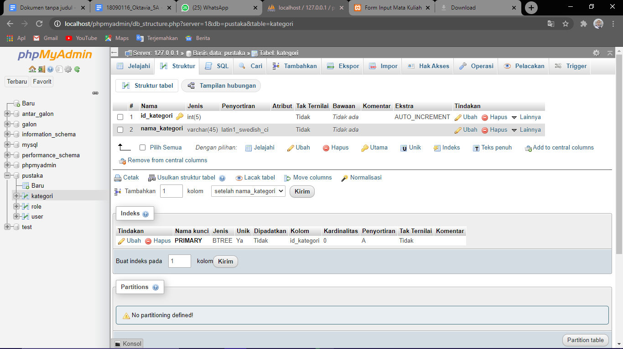

1. Tabel Buku (buku)

